REGE Foundation turns 20 – and there’s plenty to Celebrate!
This year marks the 20th year since REGE was launched, and it is timely to reflect on what has been achieved thanks to the generosity and commitment of our supporters.

Summer Update 2019
  - Issue 1
20/8/19
Over the 20 years of our partnership with local project partners Ryder-Cheshire we have successfully developed and extended our Mobile Outreach Programme to support disabled children and adults in remote areas. At one of our regular camps in October at Kashipur 40 new assessments were carried out to identify the support needs of newly identified disabled children and adults. Throughout the year we have run awareness training for nursery staff, including 250 at Khatima. We have supported parents of disabled children and are delighted that this programme will shortly be extended to reach many thousands more families in Uttaranchal.
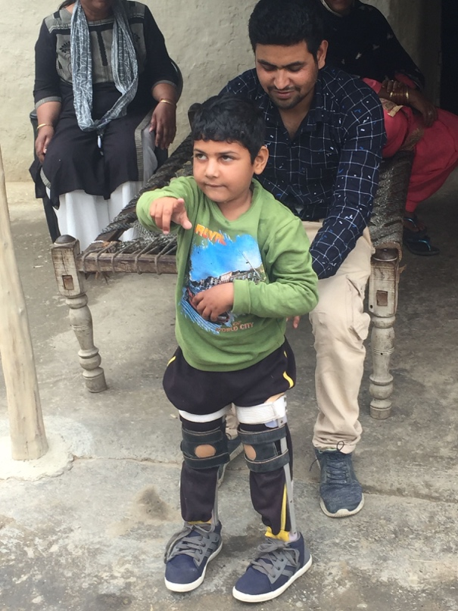

What’s to come?
From this point forwards our partnership with Ryder-Cheshire will focus on our highly successful Early Intervention Programme. Two new children, Alisha and Farhan, have recently joined the 101 children receiving regular support from our EI Programme across a range of locations. Weekly visits provide physio and occupational therapy, home support and guidance on accessing government services. By identifying disability in the first two years of a child’s life, the positive impact on the child’s growth and development is significant, sometimes eradicating any ongoing effects.
One such child is Gunjan (see below), who is five years old. She used to stay at home and the first time she left the house was when she came to the EI centre. Now she participates in the activities and has learnt to walk. Her life, and the lives of her parents, have been immeasurably enriched by allowing her to realise her potential.
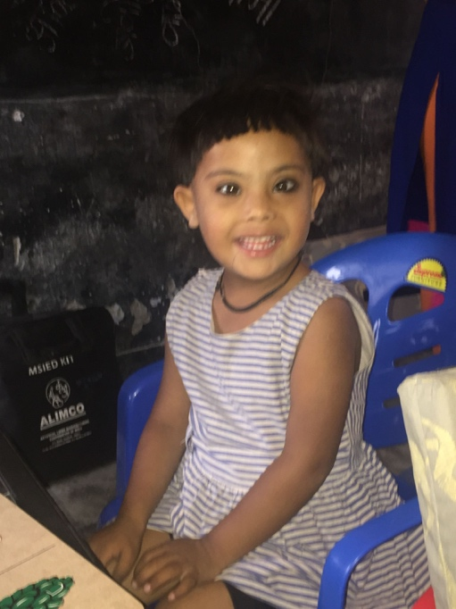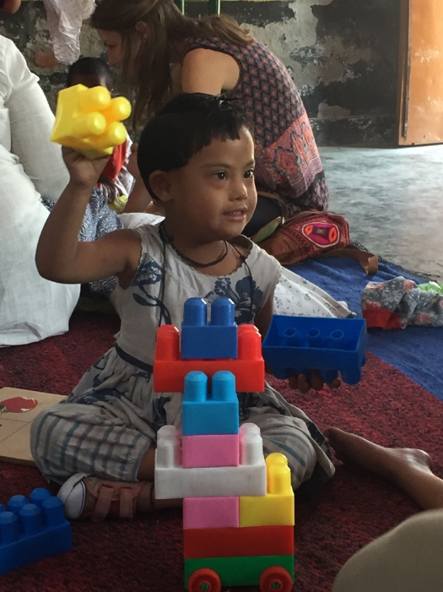

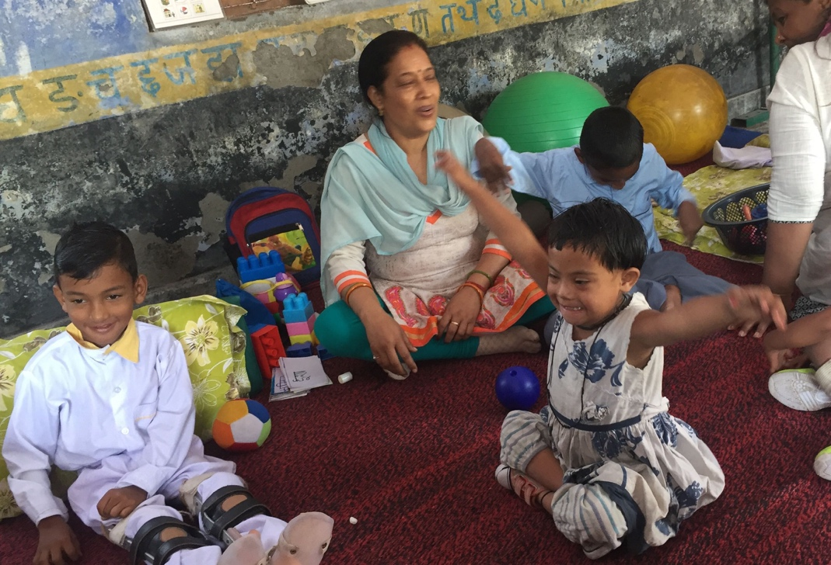
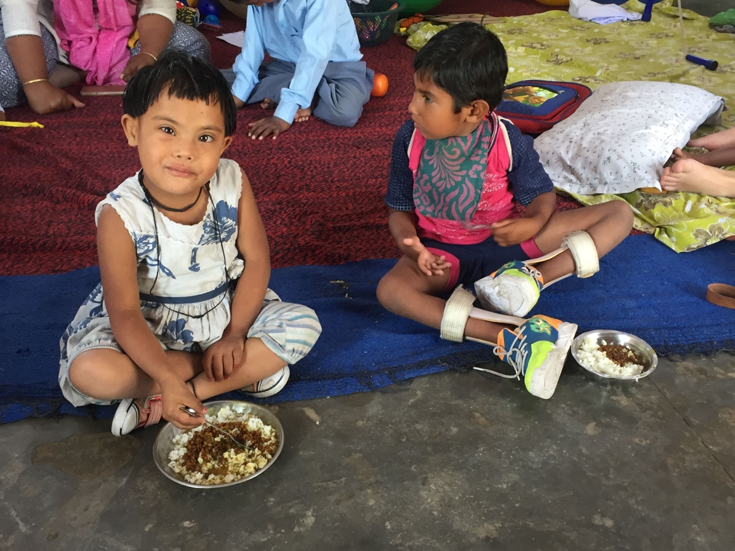

Forging new partnerships
It is exciting to announce another partnership proposal. Having worked closely with the RAD Project for a number of years to support the development of Disabled People’s Groups, we visited a number of these projects on a visit in April. The groups are run by disabled people and are often used effectively to identify small business projects in the community, based on the skills of the members, from which they can create a steady income to support themselves and their families. REGE plans to offer small grants to these groups, which can be used to fund the start-up costs of their business enterprises, such as buying equipment or investing in training. We look forward to updating you in due course!
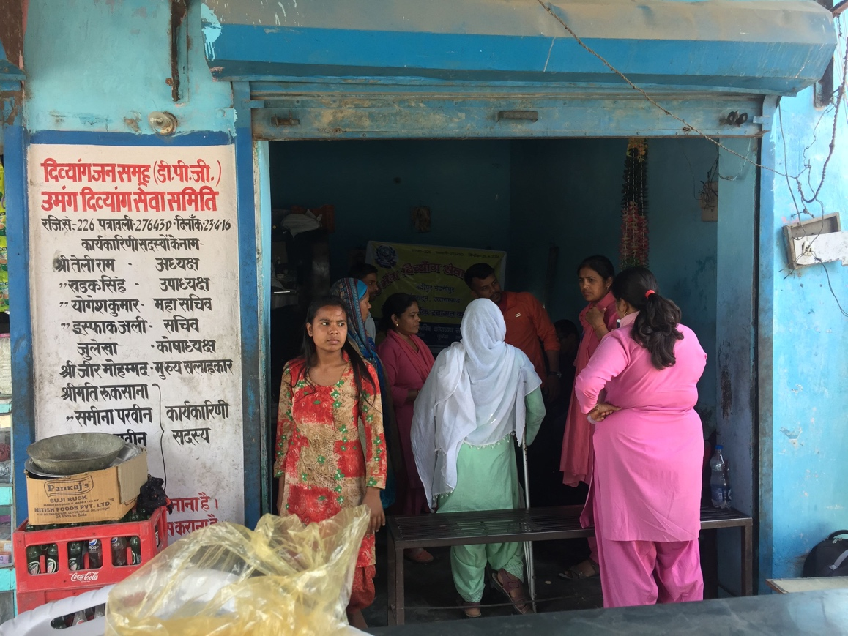
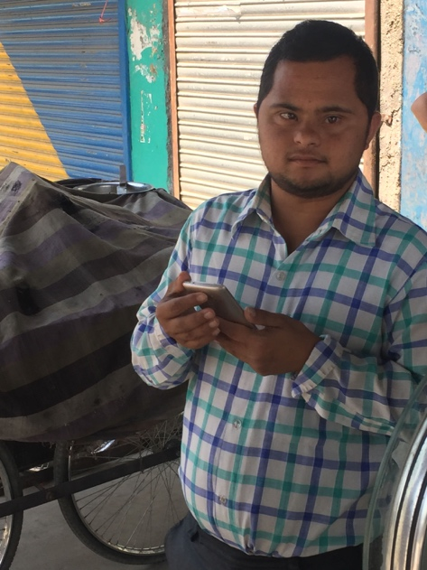
As a small charity, REGE relies on your generous support, and we would like to take this opportunity to thank you for the enormous difference your support has made to the lives of so many. Please share our story with family and friends, so that our network of supporters can grow and help us make an even bigger difference. Details can be found at www.theregefoundation.org.
Sam Woodland
Trustee and Fundraising Coordinator (volunteer)
[To unsubscribe from these updates, please reply to this email and say “unsubscribe”.]
The REGE Foundation
245 Glenfrome Road
Bristol BS5 6TP
UK

